**Military / Veteran Recruitment Best Practices; Introduction**

***AACE Spring Conference 2017***

**The Disconnect between employers/recruiters and military veterans:**

Veterans say, “I feel unprepared for a civilian career” and “the transition is fraught with confusion, fear, and lack of knowledge and information”. Employers and recruiters voice frustration at their inability to translate military skills and experiences. For both veteran and employer, the frustration often starts at the resume, to the interview, to onboarding, and to retention. There is a real disconnect; often exacerbated by impatience, lack of training, misunderstandings, stereotypes, fear, and differences. But with effort, many of these can be minimized for both employer/recruiter and veteran.

**Common Stereotypes:**

1. **PTSD:** There's stigma attached to PTSD and traumatic brain injury and other hidden disabilities that people may assume soldiers have when they're leaving the military," says Nancy B. Adams, branch chief at the U.S. Army Warrior Transition Command. "Civilian employers may always have that at the back of their mind when they hire a veteran. But, only 7% of post-9/11 veterans are estimated to be experiencing PTSD, according to the U.S. Army.
2. **Rigid/Inflexible:** Employers may also believe that veterans, used to following orders, can't take initiative and are too rigid, the SHRM survey revealed. But companies that go out of their way to recruit and hire veterans actually value their creative thinking and ability to solve unusual problems. "In the military, there's a lot of things you have to adapt to and overcome," says Joe McFarland, a former Marine and president for the Western division of Home Depot, which targets veterans in a dedicated recruitment effort. "You're put in a lot of different situations intentionally through different types of training that help you to think on your feet, that prepare you for the unexpected."
3. **Fear of future deployments:** Last but not least, many employers worry that by hiring a veteran, they may end up being short-staffed if the military reverses course and calls up former service members. "Is this veteran going to be yanked from under me and sent to deploy?" Most veterans, when they leave the military, they leave for good because they've made a decision to separate. With the current downsizing in the military, employers have little to fear. As more veterans return from overseas and seek to enter the civilian workforce, advocates like Goldenberg will continue to work against these three factors. "A lot needs to be done to dispel the stereotypes," he says. "Most vets are not damaged; they're not heroes; they're just good people who bring a lot of assets to the job."

**10 Reasons to hire (the right) veterans:**

1. **Accelerated learning curve:** Veterans have the proven ability to learn new skills and concepts. In addition, they can enter your workforce with identifiable and transferable skills, proven in real-world situations. This background can enhance your organization's productivity.
2. **Leadership:** The military trains people to lead by example as well as through direction, delegation, motivation, and inspiration. Veterans understand the practical ways to manage behaviors for results, even in the most trying circumstances. They also know the dynamics of leadership as part of both hierarchical and peer structures.
3. **Teamwork.** Veterans understand how genuine teamwork grows out of a responsibility to one's colleagues. Military duties involve a blend of individual and group productivity. They also necessitate a perception of how groups of all sizes relate to each other and an overarching objective.
4. **Diversity and inclusion in action**: Veterans have learned to work side by side with individuals regardless of diverse race, gender, geographic origin, ethnic background, religion, and economic status as well as mental, physical, and attitudinal capabilities. They have the sensitivity to cooperate with many different types of individuals.
5. **Efficient performance under pressure**: Veterans understand the rigors of tight schedules and limited resources. They have developed the capacity to know how to accomplish priorities on time, in spite of tremendous stress. They know the critical importance of staying with a task until it is done right.
6. **Respect for procedures:** Veterans have gained a unique perspective on the value of accountability. They can grasp their place within an organizational framework, becoming responsible for subordinates' actions to higher supervisory levels. They know how policies and procedures enable an organization to exist.
7. **Technology and globalization**: Because of their experiences in the service, veterans are usually aware of international and technical trends pertinent to business and industry. They can bring the kind of global outlook and technological savvy that all enterprises of any size need to succeed.
8. **Integrity**: Veterans know what it means to do "an honest day's work." Prospective employers can take advantage of a track record of integrity, often including security clearances. This integrity translates into qualities of sincerity and trustworthiness.
9. **Conscious of health and safety standards**: Thanks to extensive training, veterans are aware of health and safety protocols both for themselves and the welfare of others. Individually, they represent a drug-free workforce that is cognizant of maintaining personal health and fitness. On a company level, their awareness and conscientiousness translate into protection of employees, property, and materials.
10. **Triumph over adversity**: In addition to dealing positively with the typical issues of personal maturity, veterans have frequently triumphed over great adversity. They likely have proven their mettle in mission critical situations demanding endurance, stamina, and flexibility. They may have overcome personal disabilities through strength and determination.

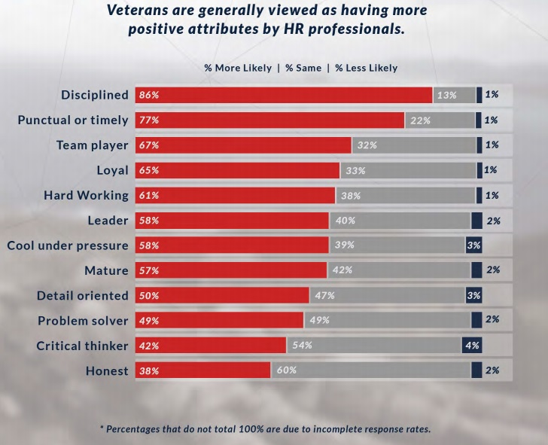

**10 Recommendations for employers/recruiters interested in recruiting, onboarding, and retaining veterans**:

1. **Don’t Hire a Veteran** if you and your organization are not committed to their success.
2. **Learn** **about the veteran experience**: Ask veterans in the company or in your network how they felt about the interview, hire and onboarding process.
3. **Train**: Train and incentivize your hiring managers to understand the challenges of the veteran candidate and develop best practices. When the applicant answers in “we” for instance, rather than first person, don’t perceive this to be evasive. Learn to ask more specific and comfortable questions to draw out their confidence.
4. **Hire the “right” veteran**: As you would any non-veteran applicant; understand not everyone is a “fit” or ideally qualified. Do your due diligence in screening for the right skills and “fit” for your company and team. Just like any applicant, don’t let stereotypes, bias, jargon, misunderstandings, or lazy interviewing to overlook a valuable source of valuable talent.
5. **Retool the application process**. Show veterans and Guard and Reservists how to apply for positions in your company. Make your application veteran friendly.
6. **Don’t say you are Veteran Friendly and you are really not:** In your marketing and recruiting efforts, show veterans what your company values are and how they can attach to them in the company. Don’t be patronizing or disingenuous. Employers that “get it” with regard to the veterans’ opportunity are willing to dedicate resources to being effective.
7. **Create a Mentorship**: Create buddy-to-buddy mentoring programs to grow your veteran employees. The military does a great job of this! Veterans are used to mentoring programs and will feel comfortable in the arrangement.
8. **Don’t just be military friendly, be military**-ready.
9. **Develop a winning military recruiting strategy.** This recruitment strategy can include attending job fairs on military installations, or posting open positions on military job boards, such as Military.com's Careers Channel.
10. **Leverage networks and your existing team members:** Ask your workforce, especially those that are former military, if they can refer any unit buddies or other veterans for open positions in your company.

**Resource Links:**

* Employer tool to translate military jobs to civilian: <https://www.onetonline.org/crosswalk/MOC/>
* Military Career Job Fair Locator (Chamber of Commerce): https://www.uschamberfoundation.org/events/hiringfairs
* Employer Support of the Guard and Reserves: <http://www.esgr.mil/>
* Military .com (commercial site, good general mil info)<http://www.military.com/>
* Miliary.com (info about hiring veterans): <http://www.military.com/hiring-veterans>
* US Dept of Labor (Employer tool kit): <https://www.dol.gov/vets/hire/index.htm>
* US Dept of Labor (Recruiting Veteran Strategies): <https://www.dol.gov/vets/ahaw/>
* Military.com (Employer Tax Credits): <http://www.military.com/hiring-veterans/resources/tax-credits-for-hiring-veterans.html>
* Syracuse University (Veteran Research and resources):<http://ivmf.syracuse.edu/>
* G.I. Jobs (Great commercial resource): <http://www.gijobs.com/>
* Society of Human Resources Management (Resources and Tools):<https://www.shrm.org/ResourcesAndTools/hr-topics/talent-acquisition/pages/veteran-hiring-hr.aspx>
* Recruiting Veterans: <http://soldierforlife.army.mil/employment>
* Army Job to Civilian Translator: <https://www.cool.army.mil/>
* PTSD: Common Employer questions: <http://www.brainlinemilitary.org/content/2013/04/common-employer-questions-about-returning-service-members-with-tbi-andor-ptsd_pageall.html>

**Military vs. Civilian Primer**

**AACE Spring Conference 2017**

Military life is like civilian life in many ways: for the most part, a servicemember works a regular job, family life, bills, housing, car and other things in order, work with other people, have a boss, and must exhibit initiative if you want to get ahead. On the other hand, the military lifestyle carries much more responsibility. There is always threat of heading to a combat zone, risking your life. You must be on time to work - there are no "getting stuck in traffic" excuses - or face punishment. You must consistently be well-groomed, live up to working and presentation standards, and talk to others according to specific rules. You usually do not have the option of saying "no" and just quitting when you feel like it. After all, you are charged with protecting the United States. If you fail, the security of the country is at stake.

**Military Organizations / Structure:**

* Hierarchical / vertical structure
* More exact rules of conduct
* Defined roles, rank & status (defined/assigned military occupational career fields)
* Consistency across units/organizations
* Clearly defined career progression
* Additionally, veterans share a bond in beliefs, traditions, values, and the importance of rank and structure

**Civilian/Non-military organization / Structure:**

* Matrix structure
* More implied or "understood" rules of conduct
* Flexible/ambiguous roles & status
* Variations across teams/divisions
* Less defined career progression / opportunity for lateral assignments
* Corporate culture imposes corporate values on the organization

**Military Ladder:** Typically, a military member rises to the top, based on a career ladder (see enlisted and officer rank chart); and most often in the same career field, i.e., intelligence, logistics, aviation, infantry, medical, administration, and such. Progression or promotion methods and promotion requirements are very defined out across each military branch and promotions are regulated by a very effective Performance Management system (based on time in service and time in rank and annual performance evaluation calculations) involving regular promotions and meritorious promotions (awarded for exceptional performance). Military promotions are based on defined performance criteria and networking or relationships rarely have anything to do with advancement. If you learn a service member has received “meritorious” promotions – he or she truly has done something exceptional and indicates a ‘high performer”.

**Civilian (non-military) Ladder:** The civilian (non-military) employment, progression, and structure after being in the very defined overall military organizational structure and progression systems can be very confusing and less defined. Often civilian employer’s performance management systems are less defined making progression obscure to a veteran. Adding to the confusion is the ever-changing organizational roles and organizational structure, even between divisions inside the same organization. Often civilian (non-military) promotions / advancements are heavily influenced by relationships, networking, and immediate needs of the team or department.

**College Education:** The majority of “Commissioned Officers” have college degrees before entering the military. But officers only make up about 30% of the total military; the other 70% are enlisted members, whose level of college education varies. 99% of enlisted members are high school graduates. Some enlisted join the military with some college credits and some have college degrees. Generally, the longer someone serves in the military, the greater the chance they have completed or are very close to completing a 4-year degree. The military encourages attending college while on active duty by offering a Tuition Assistance Program that pays for 75% of college tuition.

|  |  |  |
| --- | --- | --- |
|  | Military | Civilian |
| Pay | Basic pay, special pay. With tax advantages, pay is comparable to civilian sector pay. | Usually higher than military pay. However, there are usually no tax advantages. |
| Health Care | Several options, including full coverage that you do not pay for. | Depends on employer. Often you must pay your own, or pay partial amounts & co-pays. |
| Housing | Provided by military. If you live off base, the military provides a Basic Allowance for Housing, tax free. | Your responsibility. Usually you cover all costs. |
| Insurance | Comprehensive life insurance, all free. | Employers may or may not have insurance plans. |
| Education | G.I. Bill, branch college programs, graduate education for officers... there are endless possibilities | Your responsibility. You pay for all of it. |
| Travel | Most likely you will travel to several different base assignments to include overseas. Typical, transfer base locations every 3 years not to include deployments | Many choices, but you pay out of pocket for all of it. |
| Vacation | 30 days guaranteed vacation per year. | Varies. Most employers start you at 10-14 vacation days per year, with little increase until you have worked several years. |
| Work hours | Vary. Occasionally work weekends. You are on call 24 hours, 7 days a week. | Full-time jobs are usually 35-50 hours per week. |
| Opportunities for Advancement | Excellent! You are challenged by your leaders and peers. The choice is yours if you would like to advance or not. | Vary widely. In small companies, you may not have much opportunity. In larger companies, you may have opportunities, but often have to work much longer hours. |
| Retirement | Most can retire after 20 years of active service with 50% of base pay. Reservists can retire at 20 years but do not receive retirement until age 65. | Varies. Most employers do not offer a “retirement” but offer a 401K or other retirement savings plans with employer matching contributions. |

**Officer vs. Enlisted:** Every year more than 180,000 people enlist in the armed forces. Nearly another 20,000 become officers. Generally, Officers have a 4-year degree (and are “commissioned by the President of the United States) and serve in senior management/leadership roles and with more time in the service become “senior executives” or “commanding officers”. Generally Enlisted, enter the service from high school without a college degree and start their service in “entry level” roles but with more time in service and increased promotions in rank can become supervisors/leaders of “enlisted” personnel or senior “non-commissioned officers” in senior enlisted roles (with 15-20 years of service) become advisors to senior “commissioned” officers. In a very general sense “enlisted” are more tactical (hands-on) and “officers” are strategic and organizational planners. Generally enlisted members initially “enlist” or sign a legal agreement to serve in the military for specific periods of times; shortest period is usually 3 years; longest initial enlistment can be 6 years. Officers initially have a minimum time required to serve such as 3 years, but once the initial time is served – they can resign their commission or commitment to the military service.

**Enlisted Rank Structure (E-1, E-2, etc.), rank names, and rank symbols:**

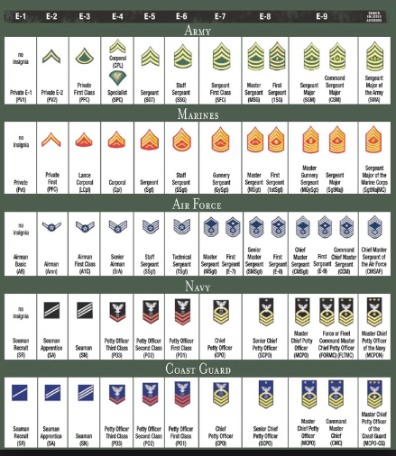

**Commissioned Officer Rank Structure (O-1, O-2, etc.), rank names, and rank symbols:**

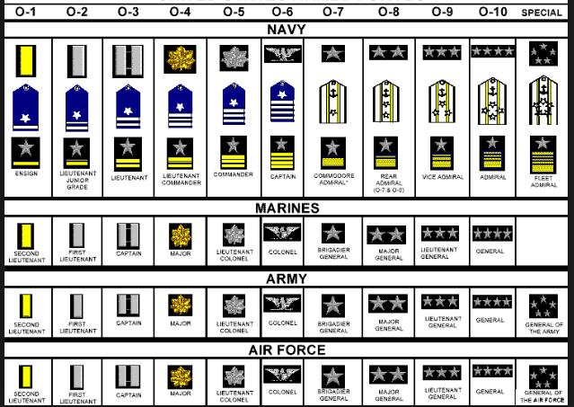

**Military Population by Rank:**

|  |  |  |  |
| --- | --- | --- | --- |
| Commissioned Officers | Total | Enlisted Personnel | Total |
| 0-1 | 24,579 | E-1 | 53,586 |
| 0-2 | 28,002 | E-2 | 80,531 |
| 0-3 | 72,729 | E-3 | 185,923 |
| 0-4 | 45,168 | E-4 | 261,890 |
| 0-5 | 28,148 | E-5 | 248,805 |
| 0-6 | 11,542 | E-6 | 175,234 |
| 0-7 | 444 | E-7 | 96,956 |
| 0-8 | 285 | E-8 | 26,912 |
| 0-9 | 132 | E-9 | 10,629 |
| 0-10 | 39 |  |  |
| Total Officer | 227,453 | Total Enlisted | 1,126,984 |

**2017 Commissioned Officer Monthly Basic Pay (not including food or housing allowance) by years of service**



**2017 Enlisted Monthly Basic Pay (not including food or housing allowance) by years of service**

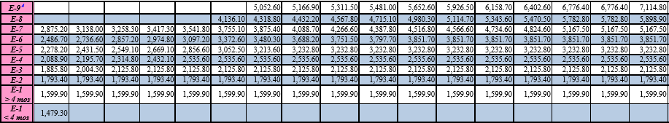

|  |  |
| --- | --- |
| Military Terms | Civilian Equivalent |
| NCOIC | Supervisor, Manager, Coordinator |
| TDY/TAD | Business Related Travel |
| Permanent Change of Station (PCS) | Relocation from one base to another base |
| Noncommissioned officer (NCO) Academy | Leadership or Management Training |
| War College | Executive Military Leadership School |
| Command and Staff College | Senior Military Leadership School |
| Basic Officers Course | Entry Level Officer Leadership Course |
| Basic Training | Introductory Military Training |
| Officer Rank: O7 and Above | President, Senior Director, Chairman of the Board, Managing Director |
| Officer Rank: O5 and O6 | Chief Executive Officer, Chief Operating Officer, Program Director |
| Officer Rank: O4 | Senior Administrator, Department Head, Program Manager |
| Officer Rank: O1 to O3 | Executive, Administrator, Manager, Project Officer |
| Enlisted Rank: E7 to E9 | Director, Supervisor, Department Manager, Operations Manager, Senior Advisor |
| Enlisted Rank: E4 to E6 | Assistant Manager, Line Supervisor, Section Leader, Task Leader, Supervisor, Foreman |
| Enlisted Rank: E1 to E3 | Production Worker, Assembler, Technician, Assistant, Apprentice, Team Member |
| Active Duty | Continuous duty on a daily basis. Comparable to "full time" as used in reference to a civilian job. |
| Allowances | Money, other than basic pay, to compensate in certain situations for expenses, such as meals, rent, clothing, and travel. Usually given for maintaining proficiency in a specific skill area, such as flying or parachuting. |
| Artillery | Large cannons or missile launchers used in combat. |
| Base | A location of an installation on which a military force relies for supplies or from where it initiates operations. |
| Basic Pay | The pay a military member receives, as determined by pay grade and length of service. Does not include other benefits such as allowance or bonuses. |
| Civilian | Anyone not on active duty in the military. |
| Commissioned Officer | A member of the military with the rank of second lieutenant or ensign or above. This role in the military is similar to that of a manager or executive. |
| Enlisted Member | Military personnel below the rank of warrant or commissioned officers. This role is similar to that of a company employee or supervisor. |
| Enlistment Agreement/Contract | A legal contract between the military and an enlistment applicant. Includes information on enlistment date, term of enlistment, and other options such as a training program guarantee or a cash bonus. |
| GI Bill Benefits | A program of education benefits for individuals entering the military. Allows service persons to set aside money to be used later for educational purposes. |
| Inactive Reserve Duty | Affiliation with the military in a non-training, non-paying status after completing minimum obligation off active duty service. |
| Infantry | Units of men trained, armed, and equipped to fight on foot. |
| Job Specialty | A specific job or occupation in one of the five services. |
| National Guard | Serves in both a state and federal capacity. May be call on to assist in community support, disaster relief, and other local emergencies. During national emergencies, units are called on to support their active counterparts in the Army and Air Force. |
| Noncommissioned officer (NCO) | Non-commissioned Officer. An enlisted member in pay grades E-4 or higher. |
| Obligation | The period of time one agrees to serve on active duty, in the reserve, or a combination of both. |
| Officers Candidate School (OCS) | Officer Candidate School. For college graduates with no prior military training who wish to become military officers. Qualified enlisted members may also attend. After successful completion, candidates are commissioned as military officers. |
| Pay Grade | A level of employment designated by the military. There are nine enlisted pay grades and 10 officers pay grades through which they can progress during their career. Pay grade and length of service determine a service member's pay. |
| Quarters | Living accommodations or housing. |
| Regular Military Compensation | Total value of basic pay, allowances, and tax savings. The amount of pay a civilian worker would need to earn to receive the same take home "pay" as a services member. |
| Reserves | People in the military who are not on full-time, active duty. May be called up in a national emergency to serve on active duty. During peacetime, they support the active duty forces in our country's defense. Reservists are also entitled to some of the employment benefits available to active military personnel. |
| Reserve Officers Training Course (ROTC) | Reserve Officers' Training Corps. Training given to undergraduate college students who plan to become military officers. Often they receive scholarships for tuition, books, fees, uniforms, and a monthly allowance. |
| Service Obligation | The amount of time an enlisted member agrees to serve in the military as stated in the enlistment agreement. |
| Station | A place of assigned duty. |
| Tour of Duty | A period of obligated service. Also used to describe a type of duty tour, such as a "Mediterranean tour." |